*A*1, *A*2, …, *An* are *attributes*

*R* = (*A*1, *A*2, …, *An* ) is a *relation schema*

ÖRNEK:

*instructor*  = (*ID, name, dept_name, salary*)

Relation instance r defined over schema R ------> r(R)

An element t of relation r is called a tuple and is represented by a row in a table

The set of allowed values for each attribute is called the domain of the attribute

Attribute values are (normally) required to be atomic; that is, indivisible

Db schema ----> logical structure of the db

instructor (ID, name, dept_name, salary)

Db instance ----> snapshot of data in db at a given time

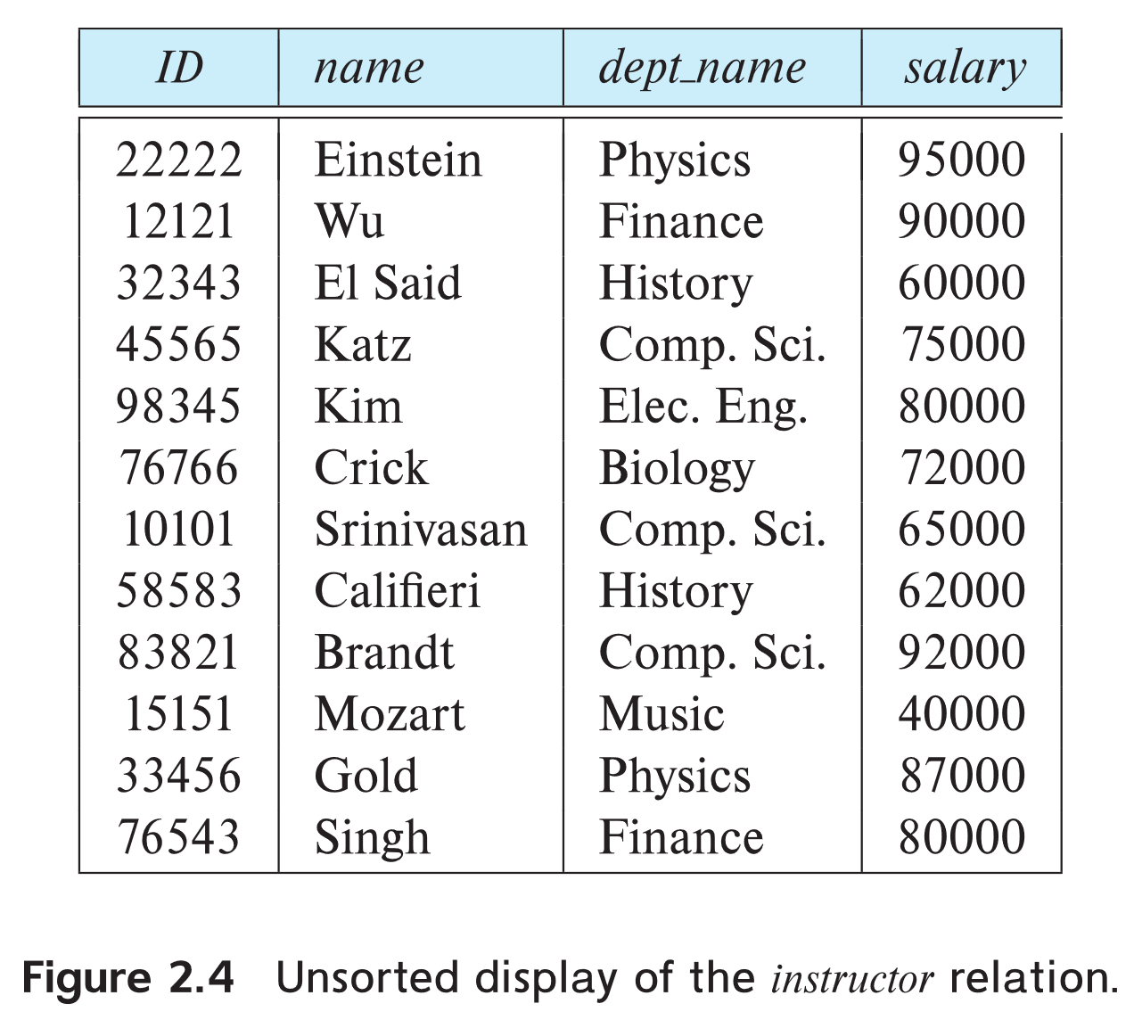

**KEYS**

Let K ⊆ R

K is a superkey of R if values for K are sufficient to identify a unique tuple of each possible relation r(R)

Example: {*ID*} and {ID,name} are both superkeys of *instructor.*

Superkey *K* is a **candidate key** if *K* is minimal

Example: {ID} is a candidate key for Instructor

Foreign key constraint: Value in one relation must appear in another

Example: dept_name in instructor is a foreign key from instructor referencing department

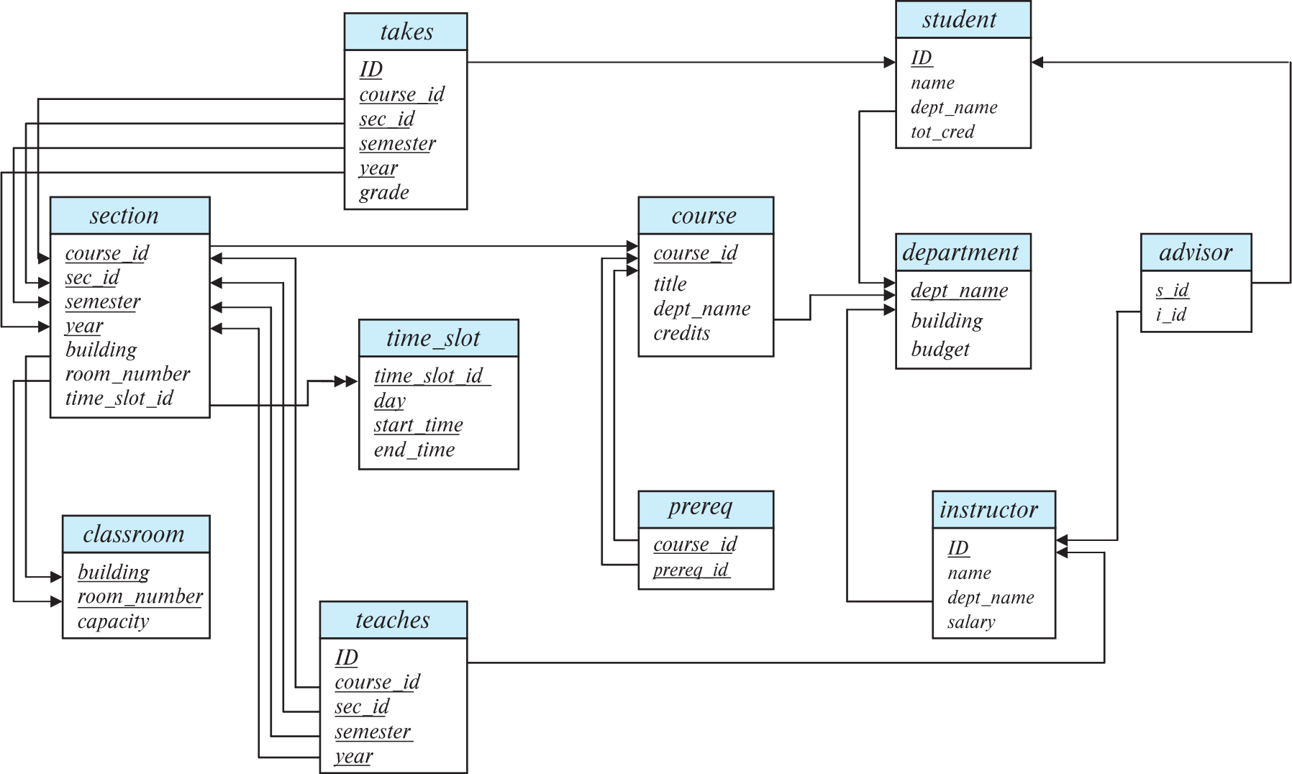

**RELATIONAL ALGEBRA**

* Six basic operators
  + select: σ
    - Select tuples that satisfy a given predicate
    - Notation: *σ* *p* (*r*)
    - p ---> selection predicate
    - Example: select those tuples of the *instructor* relation where the instructor is in the “Physics” department.
      * σ *dept_name=“Physics”* (*instructor*)
      * 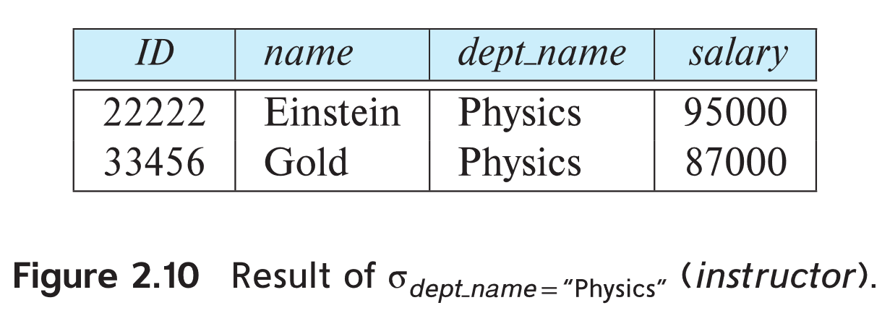
      * =, ≠, >, ≥. <. ≤
      * ∧ (**and**), ∨ (**or**), ¬ (**not**)
      * Example: Find the instructors in Physics with a salary greater $90,000, we write:
      * *σ* *dept_name=“Physics”* ∧ *salary > 90,000* (*instructor*)
      * The select predicate may include comparisons between two attributes.
        + Example, find all departments whose name is the same as their building name:
        + σ *dept_name=building* (*department*)
  + project: ∏
    - ∏ *A1,A2,A3 ….Ak* (*r*)
    - Query*:*  
         
       ∏*ID, name, salary* (*instructor*)
    - Result:
      * 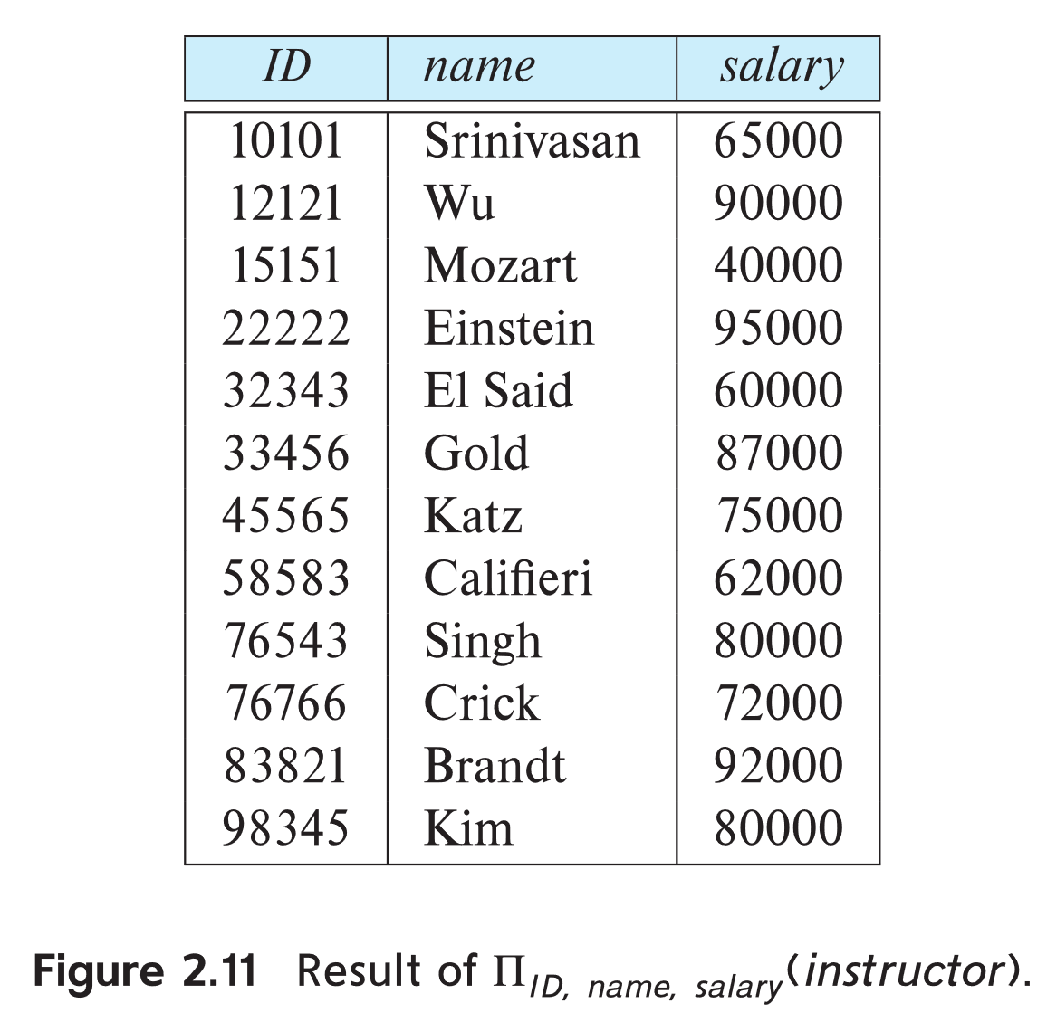
  + union: ∪
    - Same type, same number of attributes
    - Example: to find all courses taught in the Fall 2017 semester, or in the Spring 2018 semester, or in both  
       ∏*course_id* (*σ* *semester=“Fall” Λ year=2017* (*section*)) ∪   
       ∏*course_id* (*σ* *semester=“Spring” Λ year=2018* (*section*))
  + set difference: *–*
    - Same type, same number of attributes
    - Example: to find all courses taught in the Fall 2017 semester, but not in the Spring 2018 semester  
       ∏*course_id* (*σ* *semester=“Fall” Λ year=2017* (*section*)) −   
       ∏*course_id* (*σ* *semester=“Spring” Λ year=2018* (*section*))
  + set intersection: ∩
    - Same type, same number of attributes
    - Example: Find the set of all courses taught in both the Fall 2017 and the Spring 2018 semesters.

∏*course_id* (*σ* *semester=“Fall” Λ year=2017* (*section*)) ∩   
 ∏*course_id* (*σ* *semester=“Spring” Λ year=2018* (*section*))

* + Cartesian product: x
    - Example: the Cartesian product of the relations *instructor* and t*eaches* is written as:
    - *instructor* X *teaches*
    - We construct a tuple of the result out of each possible pair of tuples: one from the *instructor* relation and one from the *teaches* relation
    - 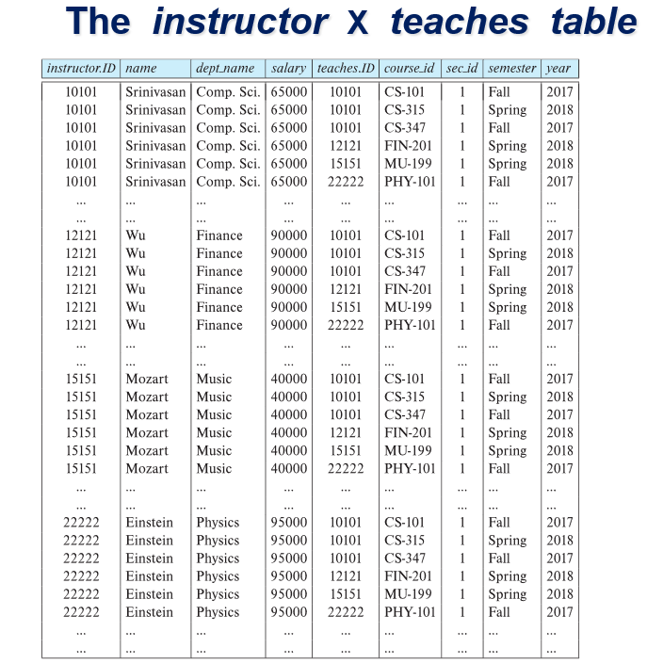
    - Şimdi burada çoğu satır kursu aslında vermeyen instructor bilgisi ile dolu.
    - sadece “instructor x teaches”’deki instructorların verdiği kursları belirten tupleları elde etmek için:
      * σ *instructor.id = teaches.id* (*instructor* x *teaches* ))
      * *instructor* *Instructor.id = teaches.id**teaches*.
        + both equal
 $r⋈_{θ}s=σ_{θ} (r × s)$

 + rename: *ρ*
    - ρ*x* (*E*)
      * returns the result of expression *E* under the name *x*
    - ρ*x(A1,A2, .. An)* (*E*)
  + assignment: 🡨
* Example: Find all instructor in the “Physics” and Music department.  
    
   *Physics* ←*σ* *dept_name=“Physics”* (*instructor*)

*Music* ←*σ* *dept_name=“Music”* (*instructor*)

*Physics* ∪ *Music*

Döndürülen yanıt is relation.

Example: Find information about courses taught by instructors in the Physics department

Query 1

*σdept_name=“Physics” (instructor* *instructor.ID = teaches.ID**teaches)*

Query 2

*(σdept_name=“Physics” (instructor))* *instructor.ID = teaches.ID**teaches*

both queries are equivalent